CENTRAL TENDENCY

The placement dataset contains information about students academic performance and placement details. To understand the overall distribution and central tendency of these numerical variables, descriptive statistical measures such as mean, median, and mode were calculated. The calculated values of mean, median, and mode for the numerical variables are shown in the table below.

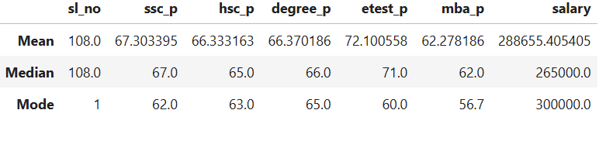

1. SSC Percentage (ssc_p)
- The mean SSC percentage is 67.30, which indicates that students scored around 67% on average in SSC.
- Since the average is above 60%, it suggests that the overall SSC performance of students is above average.
- The median is 67, meaning half of the students scored below 67% and half scored above 67%.
- The mode is 62, showing that 62% is the most frequently occurring SSC score.

2. HSC Percentage (hsc_p)
- The mean HSC percentage is 66.33, indicating that students scored around 66% on average.
- As the mean is above 60%, the overall HSC performance is above average.
- The median is 65, meaning half of the students scored below 65% and half above it.
- The mode is 63, which indicates that 63% is the score obtained by the highest number of students.

3. Degree Percentage (degree_p)
- The mean degree percentage is 66.37, suggesting that the average undergraduate score is around 66%.
- Since it is above 60%, the degree performance of students can be considered above average.
- The median is 66, indicating that half of the students scored below 66% and half above it.
- The mode is 65, which indicates that 65% is the score obtained by the highest number of students.

4. Employability Test Percentage (etest_p)
- The mean score is 72.10, indicating that students scored around 72% in the employability test.
- Since the average is above 70%, the overall performance in this test can be considered good.
- The median is 71, meaning half of the students scored below 71% and half above.
- The mode is 60, indicating that 60% is the most frequently occurring score.

5. MBA Percentage (mba_p)
- The mean MBA percentage is 62.27, which shows that students scored around 62% on average in MBA.
- Since the average is above 60%, the MBA performance is also above average.
- The median is 62, meaning half of the students scored below 62% and half above it.
- The mode is 56.7, indicating the most frequently occurring MBA score.

6. Salary
- The mean salary is ₹288,655, representing the average salary offered to placed students.
- The median salary is ₹265,000, meaning half of the placed students earn below ₹265,000 and half earn above it.
- The mode salary is ₹300,000, showing that ₹300,000 is the most commonly offered salary package.

